

TEMENOS T24

Stream

User Guide



Add Images Widget Button <Code>

Table of Contents

Introduction 3

Preface 3

Overview 3

Prerequisites 3

Assumptions 3

Getting Started 3

Creating the Add Images Widget Button 3

Executing the Add Images Widget Button 5

# 

# Introduction

## Preface

This User Guide is intended for Developers and provides the step by step instructions for adding and using the Add Images widget button, to transfer an image from the phone to the server.

## Overview

The Add Images widget enables banks to use a button to capture the image of a payee (with the camera or from a phone album) and store it in the database/core banking system, to be used on a subsequent page. Another use is in conjunction with a service such as the Remote Data Capture (remote check deposit) to take a photo of a cheque.

## Prerequisites

Distributed with the product. Therefore, there are no special installation requirements.

## Assumptions

It is assumed that you are familiar with the edgeConnect Editors and have working knowledge on edgeConnect.

# Getting Started

First, you need to create the Add Images widget button and then check how it works.

## Creating the Add Images Widget Button

To create the Add Images button:

1. Create a data item in the **DataStore Editor**, to populate with the Base64 information of the image.
2. Create a button in the **Process Editor** – this will be the element that the user clicks to add the image.

You can add rules under the button within the widgets settings. You can choose to execute these rules (if you want to) after the contact is created.

1. In the **Presentation Editor**, double-click the button and the **Presentation Button Properties** dialog opens.
2. Click **Appearance** tab -> **Button** tab.
3. In **Display Type**, choose **Camera** type.
4. In the **Widget Details** tab, you have to set up the widget settings.

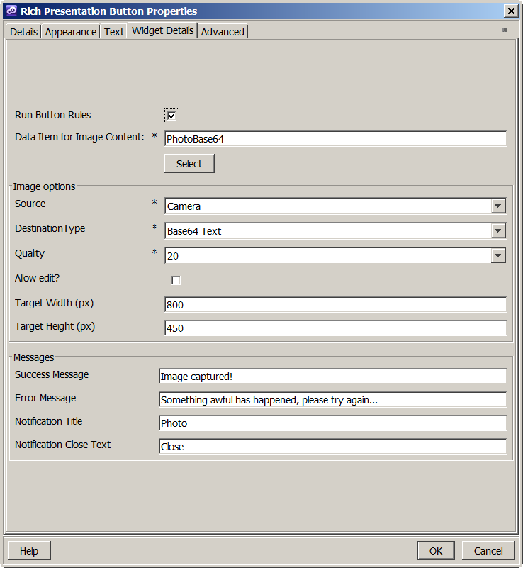

1. The first checkbox **Run Button Rules**, controls the execution of button rules (whether the button rules are executed or not) after the contact is added.
2. The next field lets the user choose the data item that stores the image information. This is a text field and needs to be exposed in the current phase, either as a question (hidden) or in the phase settings.
3. Next, you can set the origin of the picture (new from camera or existing from a photo album), quality and image size transformation. There are some limits specific to Cordova and handsets as not all of the functions are supported by all handsets.

**Note:** The Destination Type is a combo. But for now, it has a single value. We plan to add direct image transfer in the future, without converting to Base64.

1. Finally, you can add messages, which get displayed as Notes, if the image is successfully captured.

## Executing the Add Images Widget Button

When the button is generated, the standard click handler is removed, and replaced by a new event handler. This prepares the camera options, then checks to see if the destination type is DATA_URL (meaning ‘image as Base64 text’), invoking the correct method. The other option is direct image transfer to the server, which is not yet implemented. Once the image is captured (from camera or from album), it is stored in the specified Data Item, ready to be sent to the server along with the rest of the form on the screen. If this is successful, the successful message is displayed (if defined). If there was a problem, the error message is displayed (if defined). If the image was saved successfully, and the developer chose for the rules to be run, the script would have been attached to the button and the rules are executed.

In the following example, the button that uses this widget is shown as ‘Add Image Button’.

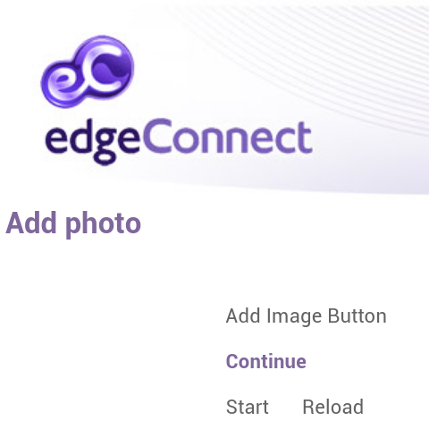

Clicking **Add Image** launches the camera, and after the image is captured, it shows the success notification.

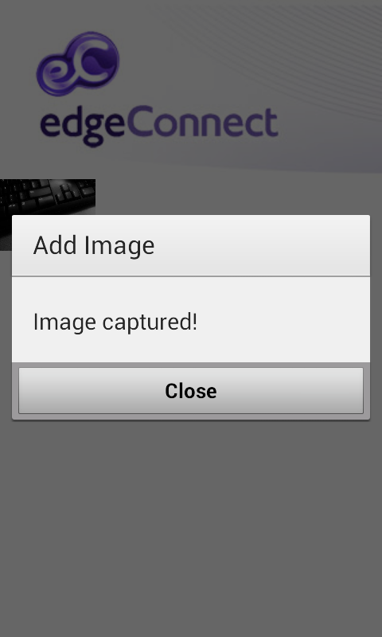

And the image is sent to the server, which can be seen on the next screen (the button runs a **Go To Phase** rule):

